**SOFTWARE PROJECT MANAGEMENT TEST**

**AKETCH MARY FRANCES**

**S20B23/215**

Question One

1. Define a statement of work and outline the work products of your course project.

A statement of work (SOW) is a document that provides a description of a given project's requirements. It defines the scope of work being provided, project deliverables, timelines, work location, and payment terms and conditions.

Products of my course project: A delivery robot

1. Elaborate 5 potential risks likely to threaten your project and how to they can be mitigated.

* Low performance. This occurs when the project doesn’t perform as well as initially expected. This can be mitigated by anticipating potential performance risks early on in the planning process can help you prepare
* High costs. This occurs when the project goes over the budget that was initially set. Cost risk can occur because of unrealistic or lack of detailed budgeting in the project planning phase. To mitigate high cost risk, estimation of each element of the project is done accurately and ensure to stick closely to the budget.
* Time crunch. This is the risk that tasks in the project will take longer than expected. To mitigate such time risk, it's better to overestimate the time needed to complete tasks in the planning phase.
* Stretched resources. Resource risk occurs if we don’t have enough resources to complete the project. The best way to mitigate resource risk is to create a resource allocation plan.
* Operational changes. This risk involves changes in company or team processes, like an unexpected shift in team roles, changes in management, or new processes that the team must adjust to. We can’t predict or prevent all operational risks, but if we know a team shift or process change is coming, we can mitigate the effects of the transition. By making sure the team is prepared for the change and has time to adjust through team meetings, scheduling tools, or additional trainings.

1. Explain the five stages of your project.

* Initiating stage: This phase is to determine the vision for my project, document what we hope to accomplish through a business case, and secure approvals from a sanctioning stakeholder.
* Planning stage: In this stage we outline and define the reason for the project by answering questions such as What exactly are we going to do? How are we going to do it? When are we going to do it? How will we know when we’re done?
* Executing stage: This is where most of the budget is allocated and most of the project deliverables are produced. Taking project plan and putting it into action, whether that takes weeks, months, or even years.
* Monitoring and Controlling stage: This is the stage where we keep an eye on the overall progress of the project
* Closing stage: This is basically checking off the project as done and closing the project down.

1. Is your project objective driven or product driven, elaborate on the difference.

* My project is objective driven.
* In a Product-driven project the project will be to create a product. The details of the product is provided by the client while in an Objective-driven project is a project to meet an objective. The Client may have a problem and asks a specialist to recommend solutions.

Question Two

1. Explain the Agile Methods
   * Kanban: Kanban is a simple, visual means of managing projects that enables teams to see the progress so far and what’s coming up next.
   * Scrum: Scrum typically uses a Scrum board, similar to a Kanban board, and groups tasks into columns based on progress
   * Extreme Programming: It focuses on continuous development and customer delivery and uses intervals or sprints, similar to a Scrum methodology.
   * Feature driven development: This methodology involves creating software models every two weeks and requires a development and design plan for every model feature.
2. Draw a product break down structure for your project

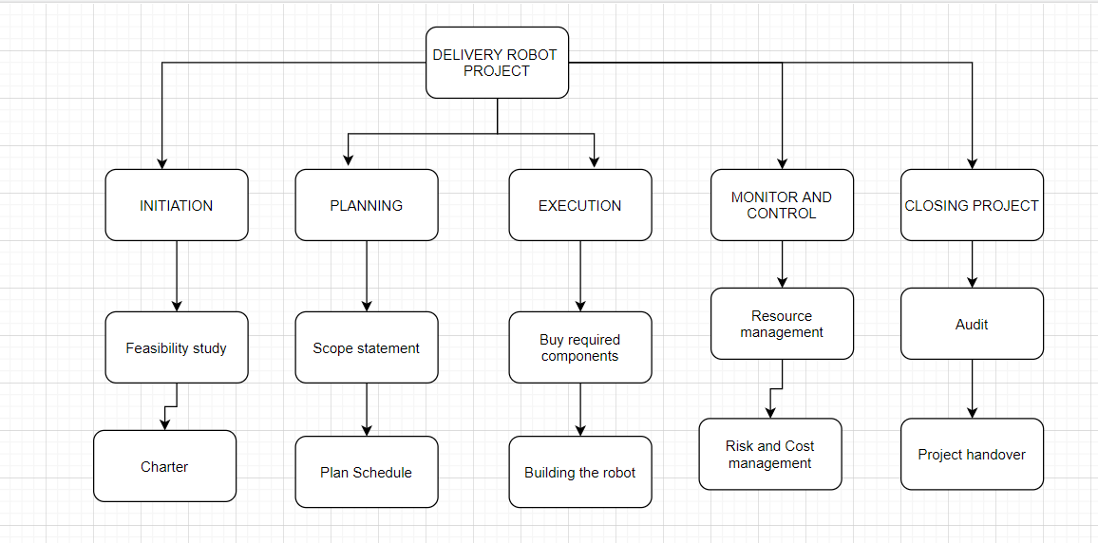

1. Draw the product flow diagram and the derived activity of work

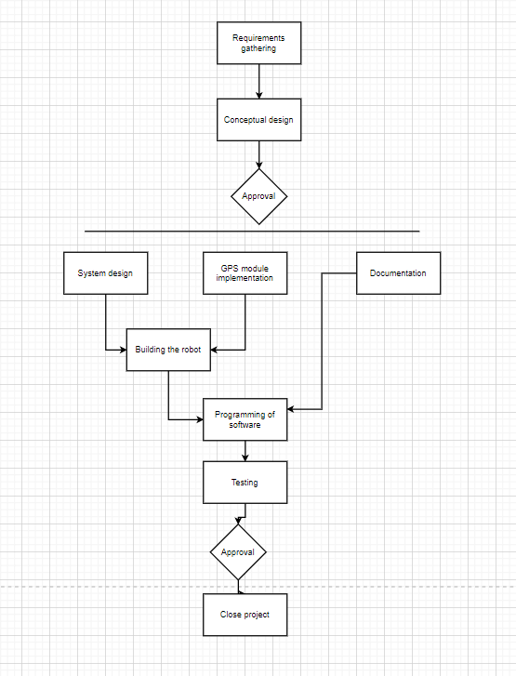

Question Three

Define the different types of contracts in software projects

* Firm Fixed Price Contracts: This type of fixed price contract is typically used in government and partial government projects where the scope is defined in detail. This makes it easy to create a request for proposals and to compare the bids you receive. The downside for this contract is that deviating from the defined scope can be expensive.
* Fixed Price Incentive Fee Contracts: With this type of fixed price contract, the buyer also offers a performance-based incentive as an extra payment to the seller. Performance can be measured for this purpose by various metrics, including time, cost, or performance.
* Fixed Price Award Fee Contracts: As with the fixed price incentive fee, this type of contract offers a bonus for exceeding a specific performance metric.
* Fixed Price With Economic Price Adjustment: With this type of contract, although the price is fixed, it can be readjusted with fluctuations in the market.